<!DOCTYPE html>
<html>
<head>
<style>
.grid-container {
display: grid;
grid-template-columns: auto auto auto auto auto auto;
gap: 10px;
background-color: #2196F3;
padding: 10px;
height: 60vh;
}
.grid-container > div {
background-color: rgba(255, 255, 255, 0.8);
text-align: center;
padding: 20px 0;
font-size: 30px;
}
.item1 {
grid-area: 1 / 1 / 6 / 2;
}
.item2 {
grid-area: 1 / 2 / 6 / 4;
}
.item3 {
grid-area: 1 / 4 / 2 / 7;
}
.item4 {
grid-area: 2 / 4 / 4 / 7;
}
.item5 {
grid-area: 4 / 4 / 6 / 7;
}
</style>
</head>
<body>
<h1>The grid-area Property</h1>
<p>You can use the <em>grid-area</em> property to specify where to place an item.</p>
<p>The syntax is:</p>
<p>grid-row-start / grid-column-start / grid-row-end / grid-column-end.</p>
<p>Item8 will start on row-line 1 and column-line 2, and end on row-line 5 column-line 6:</p>
<div class="grid-container">
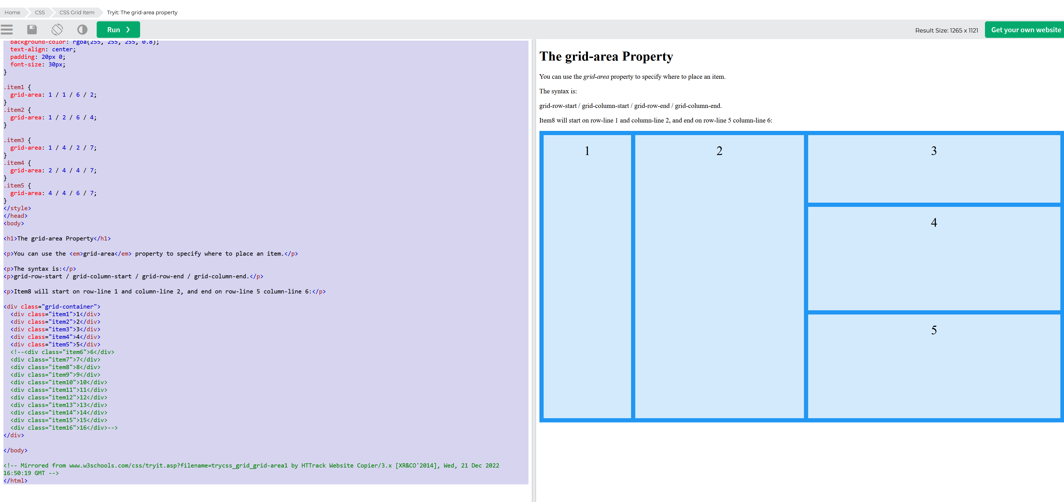
<div class="item1">1</div>
<div class="item2">2</div>
<div class="item3">3</div>
<div class="item4">4</div>
<div class="item5">5</div>
</div>
</body>
</html>

